Gold Coast Model Railway Club Inc
Membership Application
upstairs clubrooms  Unit 27/316 BRISBANE RD  Arundel (entry via Kendor St)  gcmrctrains@gmail.com |  |  |  | 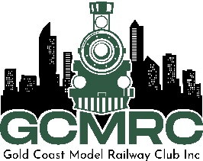 |  |  |  |  | - Postal Address  PO Box 1585  Runaway Bay  Qld 4216
Applicant Information

Type of membership |  | Junior € Adult € Distance €  (Under 18 Yrs) |  |  |  |  |  |  |  | Family €
 |  |  |  |  |  |  |  |  |  | Name: |  |  | Interest:
Name:
Phone: |  | Fax: |  |  | Mobile:
Current Address:
City: |  |  | State: |  |  | Post Code:
Email: |  |  |  |  |  |  | Date of Birth:
Emergency Contact

Name of Contact:
Address:
City: | State: |  |  |  |  |  | Post Code: |  |  | Phone:
Relationship:
Special skills That You Bring To The Club, e.g. scenery, electrics, modeling etc…
Your Hobby Interest Information

Prototype: |  |  |  |  |  |  |  | Scale: |  |  |  | Occupation:
I agree to abide by the constitution, by-laws and terms and conditions of the Club.  Signature of Applicant: |  |  |  |  |  |  |  |  |  |  | Date:
Signature of Parent if member is under 18 |  |  |  |  |  |  |  |  |  |  | Date:
- Office Use Only

New Members = $50.00 (admin fee)  Junior Under 18Yrs = $66.00: Adult = $165.00; Distance $66.00  Family = $220.00  Total $ |  |  |  |  |  |  |  |  |  |  | Amount paid:  Membership #
Nominated by:  Seconded by: |  |  |  |  |  |  |  |  |  |  | Date:
BANK TRANSFER DETAILS: BENDIGO BANK BSB 633 108 AC:119291961

